
NAME : VAANI JINDAL
SAP : 500119144
BATCH : 2
SUBJECT : OOPS

EXPERIMENT -3

- Ques 1: Write a Java program to find the second largest element in an integer array without sorting the array, if not exist return -1.

Example:
Input: arr = {12,32,22,54,39,53,19}
Output: 53
Code: 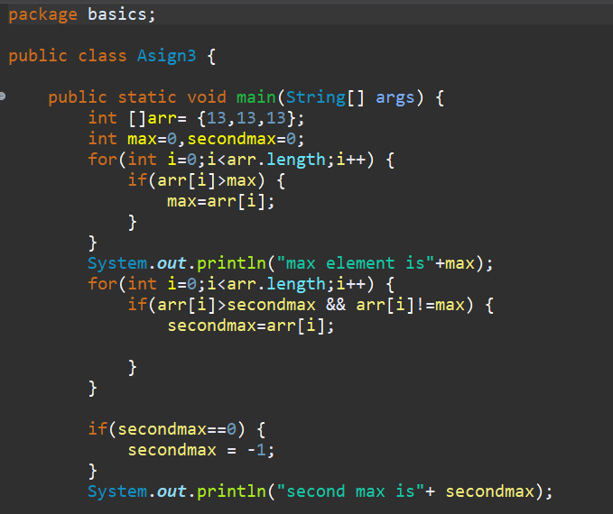
Output:
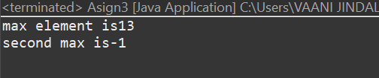
- Ques 2: Given a string, check if the string is palindrome or not." A string is said to be palindrome if the reverse of the string is the same as the string.
Example 1:
Input: Str = “LEVEL”
Output: Palindrome

Example 2:
Input: Str = “SATYAM”
Output: Not Palindrome
Code :
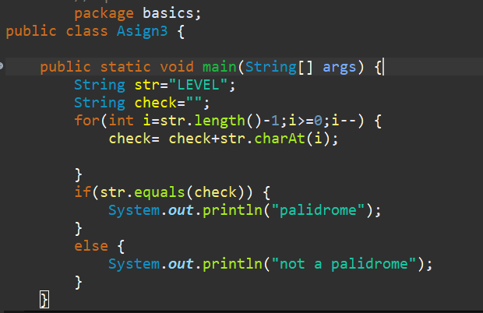
Output:
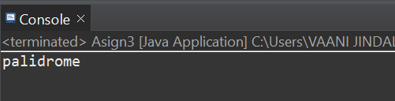
Ques : Remove Duplicate Elements in Unsorted Array.
Example:
Input: arr[] = {2,1,3,5,5,3,2,7,2,8,7,5}
Output: arr[] = {1,2,3,5,7,8}
Code :
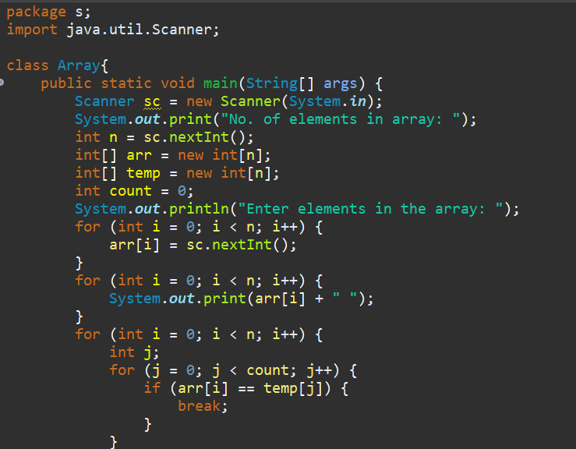
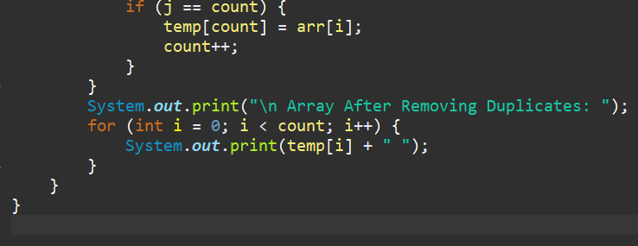

Output:
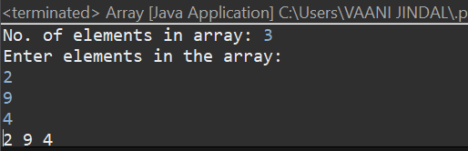

Ques : Write a Java program to rotate an array right by K positions.
Example:
Input: arr = [1, 2, 3, 4, 5], K = 2
Output: [4, 5, 1, 2, 3]
Code :
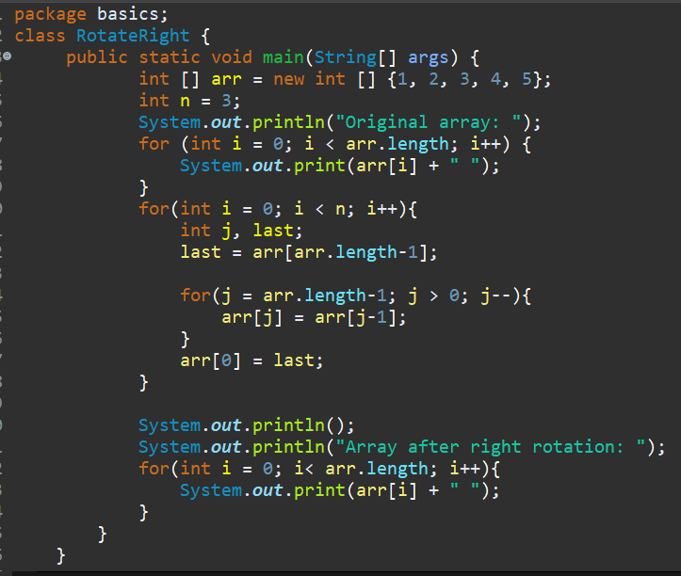
Output:
